**Lab 10 – SQL**

**Each problem is worth one point. No partial credit will be given. This lab is worth a total of 20 points.**

**From this lab forward, please notice if a result table is in a particular order. If it is you must use the order by clause. Failure to do so will result in 0 points for that specific problem.**

**Place all answers into ONE .sql file. Attach that file to Dropbox for Lab 10 in D2L. Only one .sql file will be accepted.**

**\*\*\*\* Use the HR table space for the following questions \*\*\*\***

**1. Display the approximate hours a person has worked. Assume 2000 hours per year is**

**worked by an individual. Use the Job_History table.**

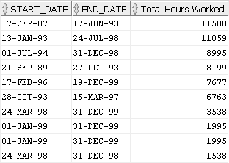

**2. Display all employees whose first name starts with a ‘J’ and whose commission rate is**

**greater than 10%. Use the Employees table.**

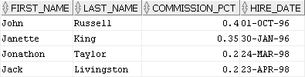

**3. Display all employees whose first name starts with a ‘J’ and whose commission rate is**

**greater than 10% and whose last name contains an ‘o’ and whose was hired after June 1,**

**1996. Use the Employees table.**



**4. Display the last letter of all region names that are longer than 4 characters. Use the**

**Regions table.**

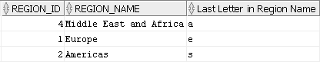

**5. Using LPAD and RPAD, recreate the following result table for department 100. Use the**

**Employees table.**

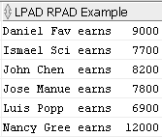

**6. Calculate a bonus for each employee by using the number of days since they were hired.**

**The employee receives $2 for each day they have been with the company. Assume this**

**query is run on June 1, 2010. Use the Employees table.**

**Partial result table (107 rows total)**

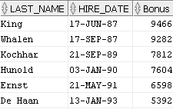

**7. Display team numbers for all employees. Team numbers are found by dividing the**

**employee id by four. If 4 divides the employee id evenly, then that employee is part of**

**team 1. For the other cases, a remainder of 1 places that employee on team 2, etc. Use**

**the Employees table.**

**Partial result table (107 rows total)**

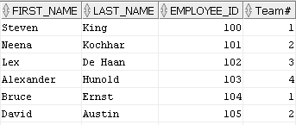

**8. Using question 7 as a starting point, display the number of employees on each team.**

**Use the Employees table.**

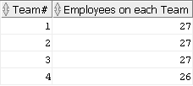

**9. Display the following result table. Use the Employees table.**

**Partial result table (107 rows total)**

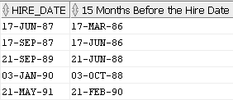

**10. Display all employees as either someone that earns a commission or someone that does**

**not earn a commission. Use the Employees table.**

**Partial result table (107 rows total)**

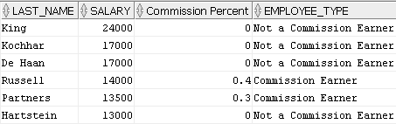

**11. Display the number of employees employed each year. Use the Job_History table.**

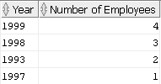

**12. Display the job id of employees having an average salary of more than $10,000 and there**

**must be more than one employee with that job id. Use the Employees table.**



**13. Using a NATURAL JOIN, join the tables Regions and Countries. Only select a country name**

**of Canada. Use the Regions and Countries tables.**



**14. Display all employees that are part of a department. Show any employees that are not**

**part of a department also. Use the Departments and Employees tables.**

**Partial result table (123 rows total)**

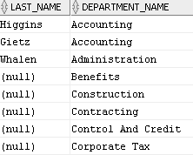

**15. Using question 14 as a starting point, display any employees that are not currently**

**assigned to a department. Use the Departments and Employees tables.**



**16. Display all managers that are in department 20 or 30, but not in department 50. You**

**must use SET OPERATORS to receive credit. Use the Employees table.**



**17. Display all administration employees. Use the Employees table.**

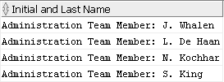

**\*\*\*\* Use the Dual table for the following questions \*\*\*\***

**18. Display the number of seconds in a year. Use the Dual table.**



**19. Starting with the date/time of July 20, 2001 10:40:12, display the following result table.**

**Use the Dual table.**



**20. Display May 13, 2015 as per the following result table. Use the Dual table.**

